

**RTLB Lead School Forum Presentation**

**Approaches to appraisal evidence for Resource Teachers of Learning & Behaviour**

Chris Thornley, Principal Advisor Teacher Education

8 March 2016

With thanks to developers and facilitators from:

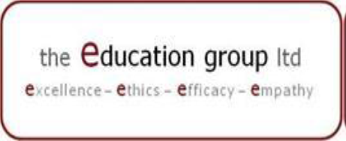





***Appraisal Conceptual Framework He Kete Whakatipu Ngaio Tangata***

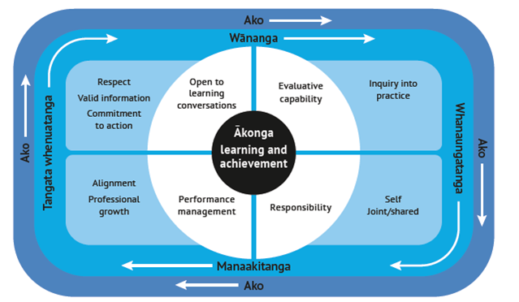

http://educationcouncil.org.nz/appraisal-teachers-projectFollow tab for Phase One, then Webinar 1 as support for this framework

 Follow tab for Principals to find this appraisal components diagram

Getting to know the *Practising Teacher Criteria*

(i) Underline 2 or 3 words that reflect the essence of each criterion

(ii) How are criteria 1 – 5 different from 6 – 12?

Getting to know *Tātaiako: Cultural Competencies for Teachers*

|  |  |
| --- | --- |
| **What do these competencies look like in RTLB practice?** | **Which *PTC* do they link to?** |
| **Work with a partner on this task** | |
| **Wānanga** |  |
| **Manaakitanga** |  |
| **Whanaungatanga** |  |
| **Tangata whenuatanga** |  |
| **Ako** |  |

What does quality Resource Teacher of Learning and Behaviour practice look like?

[*http://www.educationcouncil.org.nz/appraisal-teachers-project*](http://www.educationcouncil.org.nz/appraisal-teachers-project) Follow Resources tab to find this template called *Knowing and working with the PTC*

|  |  |  |  |  |  |
| --- | --- | --- | --- | --- | --- |
| ***Professional relationships and professional values***  **Fully certified teachers engage in appropriate professional relationships and demonstrate commitment to professional values** | | | | | |
| **Criteria** | **Key indicators** | **Reflective Question** | **Tātaiako – cultural competency** | **What quality practices do you use in your setting that connect with these criteria and competencies?** | **What would you regard as valid evidence that you could use to demonstrate these quality practices?** |
| **Criterion 3.**  demonstrate commitment to bicultural partnership in Aotearoa New Zealand | i. demonstrate respect for the heritages, languages and cultures of both partners to the Treaty of Waitangi | How do I reflect in my professional work respect for the cultural heritages of both Treaty partners in Aotearoa New Zealand? | TANGATA WHENUATANGA: affirms Māori learners as Māori- provides contexts for learning where the identity, language and culture (‘cultural locatedness’) of Māori learners and their whanau is affirmed |  |  |

|  |  |  |  |  |  |
| --- | --- | --- | --- | --- | --- |
| **Criteria** | **Key indicators** | **Reflective Questions** | **Tātaiako – cultural competency** | **What quality practices do you use in your setting that connect with these criteria and competencies?** | **What would you regard as valid evidence that you could use to demonstrate these quality practices?** |
| **Criterion 6**.  conceptualise, plan and implement an appropriate learning programme | i. articulate clearly the aims of their teaching, give sound professional reasons for adopting these aims, and implement them in their practice  ii. through their planning and teaching, demonstrate their knowledge and understanding of relevant content, disciplines and curriculum documents | What do I take into account when planning programmes of work for groups and individuals? | AKO: Takes responsibility for their own leaning and that of Māori learners |  |  |

***Organising a Package***

**Examples of practice could be…**

For a teacher: a unit of teaching

leading an innovation in the school,

participation in and changed practice from PLD

For an RTLB: a case review,

a response to request for support

an inquiry

………………………

1. Matched to each *PTC*
2. Matched to the cultural competencies of *Tātaiako*
3. Organised around goals
4. Organised around inquiry
5. Organised around an ‘**example of practice’**
6. As an amalgam of holistic and individual *PTC* grouped evidence

***Example of practice: Which criteria can you see? What evidence is produced?***

Elise, the Resource Teacher of Learning and Behaviour was allocated by her Cluster Manager a request for support from a school who had identified the need for teacher professional learning in the area of junior literacy.

She had worked with the school previously and was aware that the students’ literacy learning and achievement was varied. Through the request for support the school was hoping to address the needs of a group of junior school students who were not reading at the levels needed for their ongoing school success. The school felt from their discussions with the RTLB and the Cluster Manager in the past that this systems approach would benefit a wider group of students than individual referrals.

Elise was really pleased to have this request as it linked directly to one of her own appraisal goals. She was wanting to build her inquiry around developing her understanding of how to successfully teach students who were facing challenges in their literacy learning. She already had started reading research articles and had attended a conference workshop by someone with expertise in this domain.

In preparing for the meeting Elise considered four main things:

* her clarity about the intention for the support
* ensuring she was as knowledgeable about the content (junior literacy) as she could be
* making sure the teachers were as prepared as they could be to fully participate
* considering how she could optimise the learning opportunity through the establishment of effective relationships with the teachers.

She arranged a meeting with the Principal to make sure she was clear about the request. Following that, the teacher meeting was arranged to set up the plan for the support. Beforehand, she talked with the teachers individually to make sure they knew to bring relevant data that would include achievement information, planning, observations and notes. She also was checking in to get a sense of their aspirations for the work together.

In preparing for the meeting Elise also went back to the notes she had from the cluster’s PLD focus on ako as one of the *Tātaiako* cultural competencies. She looked also at the work on culturally responsive practices that they had done as part of their annual marae visit. This all informed the relationships she established with colleagues which would be really important to the success of the professional learning.

After the initial teacher meeting, she knew she needed to work with the teachers more on the data gathering and analysis, and she set up a timeframe for that. However, she also needed to keep working on the resources she was developing to support the teaching, so she prioritised that. When she mentioned the workshop that she had attended at the conference, the teachers thought this would be very relevant to them and their students. The preliminary data they had shared certainly confirmed that.

In talking with some of her colleagues, about where she had got to in this response, many of them indicated that they would benefit from this workshop too. So Elise prepared a proposal for the Cluster Manager to consider bringing the workshop presenter to their area as a PLD opportunity for the other RTLB and the teachers…

***Evidence Analysis Tools***

**What Stands Out?**

From everyday practice: What is available as evidence?

Identification:

What stands out?

What patterns can I see for me,

my group of ākonga and

individual ākonga/priority learners?

Reflection:

What does this mean for next steps teaching and learning?

How does this meet

the PTC/Tātaiako?

***Evidence Analysis Tools***

**Sources and Perspectives?**

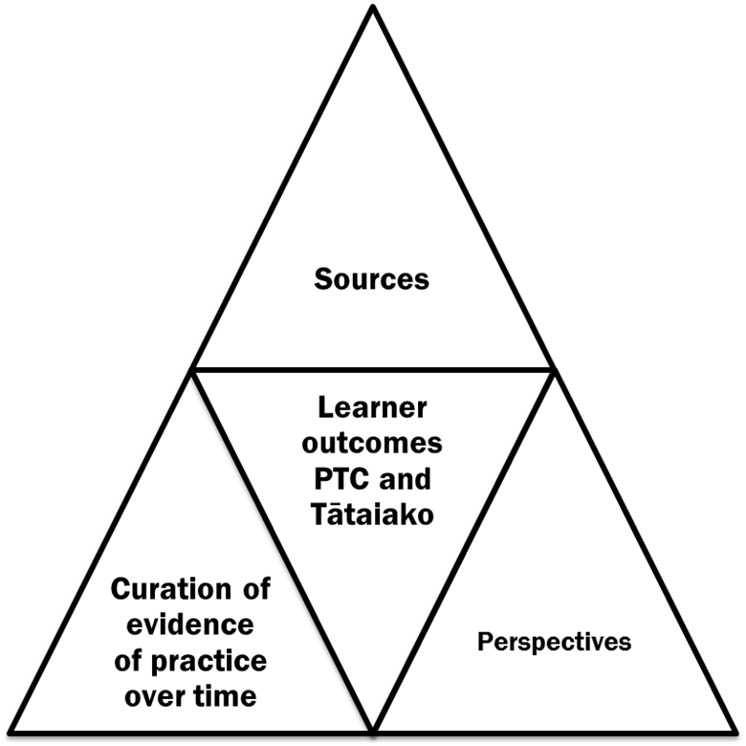

***Backward Mapping***

**Option One**

|  |  |  |
| --- | --- | --- |
| **Goals:** | | |
| **Backward Mapping Evidence for *Practising Teacher Criteria and Tātaiako*** | | |
|  | | ***Comments and Dates*** |
| 1 | **Establish and maintain effective professional relationships focussed on the learning and well-being of all ākonga** |  |
| 2 | **Demonstrate commitment to promoting the well-being of all ākonga** |  |
| 3 | **Demonstrate commitment to bicultural partnership in Aotearoa New Zealand** |  |
| 4 | **Demonstrate commitment to ongoing professional learning and development of personal professional practice** |  |
| 5 | **Show leadership that contributes to effective teaching and learning** |  |
| 6 | **Conceptualize, plan and implement an appropriate learning programmes** |  |

|  |  |  |
| --- | --- | --- |
|  | | ***Comments and Dates*** |
| 7 | **Promote a collaborative inclusive and supportive learning environment** |  |
| 8 | **Demonstrate in practice their knowledge and understanding of how ākonga learn** |  |
| 9 | **Respond effectively to the diverse language and cultural experiences, and the varied strengths, interests and needs of individuals and groups of ākonga** |  |
| 10 | **Work effectively within the bicultural context of Aotearoa New Zealand** |  |
| 11 | **Analyse and appropriately use assessment information which has been gathered formally and informally** |  |
| 12 | **Use critical inquiry and problem solving effectively in their professional practice** |  |

***Backward Mapping***

**Option Two**

|  |  |  |  |  |  |  |  |  |  |  |  |  |
| --- | --- | --- | --- | --- | --- | --- | --- | --- | --- | --- | --- | --- |
| **Tātaiako**  **Cultural competency** | **Whanaungatanga** | **Manaakitanga** | **Tangata whenuatanga** | **Ako** | **Wānanga** | **Ako** | **Manaakitanga** | **Ako** | **Tangata whenuatanga** | **Tangata whenuatanga** | **Wānanga** | **Wānanga**  **Ako** |
| **PTC** | **1**  **relationships** | **2**  **well being** | **3**  **Treaty** | **4**  **ongoing PD** | **5 leadership** | **6**  **learning plans** | **7**  **Inclusive environment** | **8**  **learning** | **9**  **diversity** | **10**  **bicultural** | **11**  **assessment** | **12**  **inquiry** |
|  |  |  |  |  |  |  |  |  |  |  |  |  |
|  |  |  |  |  |  |  |  |  |  |  |  |  |

***Appraisal Conversation Guide***

1. The progress my ākonga have made so far this year. Especially my priority learners. How I know that they are progressing.
2. The extent to which my ākonga can talk about their learning in ways that indicate the growth of self-regulation and key competencies and that their culture, identity and languages are respected.
3. My inquiry. How it is going? What I have noticed about my changed practice and the impact on my ākonga?
4. The various sources and perspectives I have used in my evidence.
5. Reflecting on this evidence, how has it impacted on my practice and what might my next steps will be?
6. How all of my evidence provides information that will help me set my next learning goal/inquiry into practice.
7. How what I have shared with my appraiser shows I have met the *PTC* and the *Tātaiako* cultural competencies.
8. The PTC not represented in my evidence to date and what I might need to do about this.

***Annual Appraisal Summary Report: Sample Template***

|  |  |
| --- | --- |
| **Appraisee:** |  |
| **Appraiser:** |  |

***List of possible evidence verified by appraiser***

*These aspects are independently verified as being completed during the appraisal period (keep files accessible for review)*

|  |  |  |  |  |  |  |
| --- | --- | --- | --- | --- | --- | --- |
| **Evidence sources** | **Student assessment records and work samples** | **Analysis of summative student achievement data** | **Planning documentation** | **Observations of practice and feedback** | **Meeting notes** |  |
| **Perspectives (listed)**  **e.g. Students, colleagues, parents** |  |  |  |  |  |  |

**General Review** *- appraisee to complete*

**Aspects of the year that were most rewarding or satisfying and why?**

**Aspects of the year that were the least rewarding or satisfying and why?**

**Summary of contributions** *– curriculum/pastoral/co-curricular*

*Appraisee/appraiser to complete after discussion* - *related to the responsibilities and Practising Teacher Criteria*

|  |  |  |
| --- | --- | --- |
| ***Tātaiako/PTC*** | **Comments**  **(impact on learners)** | **Next steps**  **(for teaching and learning)** |
| Whanaungatanga (PTC 1) |  |  |
| Ako  (PTC 4,6,8,and 12) |
| Tangata Whenuatanga  (PTC 3,9 and 10) |
| Manaakitanga  (PTC 2, 7) |
| Wānanga  (PTC 5, 11 and 12) |

*Appraisee/appraiser to complete after discussion*

|  |  |
| --- | --- |
| **Objective** (copy and paste from Portfolio) | **Evaluation/Comment** on achievement |
|  |  |

**Areas for future development -** *appraisee/appraiser to complete after discussion*

|  |
| --- |
|  |

**Closing remarks****-** *appraiser to complete after discussion*

**With reference to the evidence and discussion between appraisee and appraiser all PTC have been met.**

OR

**With reference to the evidence and discussion between appraisee and appraiser the following PTC have not YET been evidenced.**

**Comments** - *timeframe, action and support to be identified here*

**Signatures Date**

|  |  |
| --- | --- |
|  |  |
|  |  |